Empowering India: Analysing the Evolution of Union Budget Allocation for Sustainable Growth

Define the Problem / Problem Understanding

India’s development and economic stability largely depend on effective financial planning by the government. The Union Budget of India is a key financial statement that presents the government’s revenue, expenditure, and policy priorities for each financial year. Budget allocations to critical sectors such as education, healthcare, agriculture, infrastructure, and renewable energy directly influence the nation’s sustainable growth.

Over the years, the Union Budget has undergone significant changes to address emerging economic challenges, population growth, and environmental concerns. However, analyzing the evolution of budget allocations across multiple years and sectors becomes complex due to the large volume of data involved. Without proper analysis, it is difficult to understand trends, patterns, and shifts in government priorities.

This project aims to understand the problem of identifying meaningful insights from historical Union Budget data by applying data analytics techniques. The study focuses on analyzing year-wise and sector-wise budget allocations to evaluate their contribution toward sustainable economic and social development in India.

Specify the Business Problem

The government of India allocates a significant portion of its financial resources through the Union Budget of India to various sectors that influence economic growth and sustainability. However, decision-makers, researchers, and analysts face difficulty in understanding how budget allocations have changed over time and which sectors receive priority in different years.

The business problem addressed in this project is the lack of a clear, data-driven view of historical budget allocation trends across key sectors such as education, health, agriculture, infrastructure, and renewable energy. Without proper analysis and visualization, it becomes challenging to assess whether the budget allocations align with the goals of sustainable development.

This project aims to solve this problem by using data analytics techniques to analyze historical Union Budget data, compare sector-wise allocations, identify trends, and present insights in an easy-to-understand visual format. The analysis helps stakeholders evaluate government spending priorities and their contribution to India’s sustainable growth.

Business Requirements

The successful execution of this project requires a clear understanding of the business and technical requirements needed to analyze Union Budget allocation data effectively. The primary business requirement is to evaluate how financial resources allocated through the Union Budget of India contribute to sustainable economic and social development in India.

The project requires historical budget allocation data across multiple years for key sectors such as education, healthcare, agriculture, infrastructure, and renewable energy. This data must be accurate, well-structured, and suitable for analysis. Proper analytical tools are required to process the data, identify trends, and generate meaningful insights.

From a technical perspective, the project requires data storage in a structured format, data cleaning and preparation, and the use of data analytics tools for visualization. The output should include clear charts and graphical representations that help in comparing year-wise and sector-wise budget allocations. These requirements ensure that the analysis supports informed decision-making and aligns with the objective of sustainable growth.

The use of a data analytics tool for analyzing Union Budget allocation data. The dataset is processed using analytical techniques to identify trends and patterns across different sectors and years. Visualization tools such as charts and graphs are generated to compare budget allocations and understand government spending priorities. This step helps in transforming raw data into meaningful insights that support sustainable growth analysis.

Dataset Creation
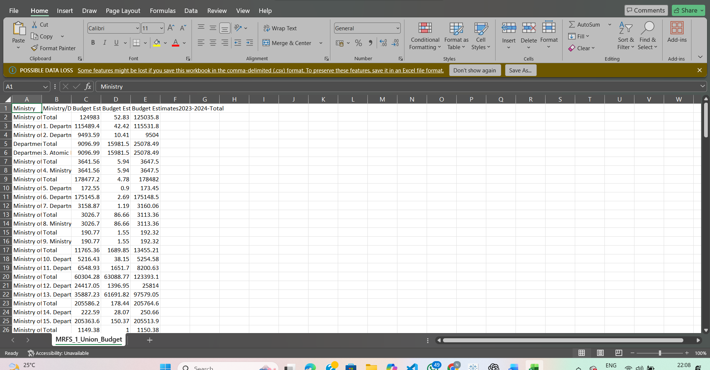
Fig 1: Sample Union Budget Allocation Dataset

Data Analysis Tool

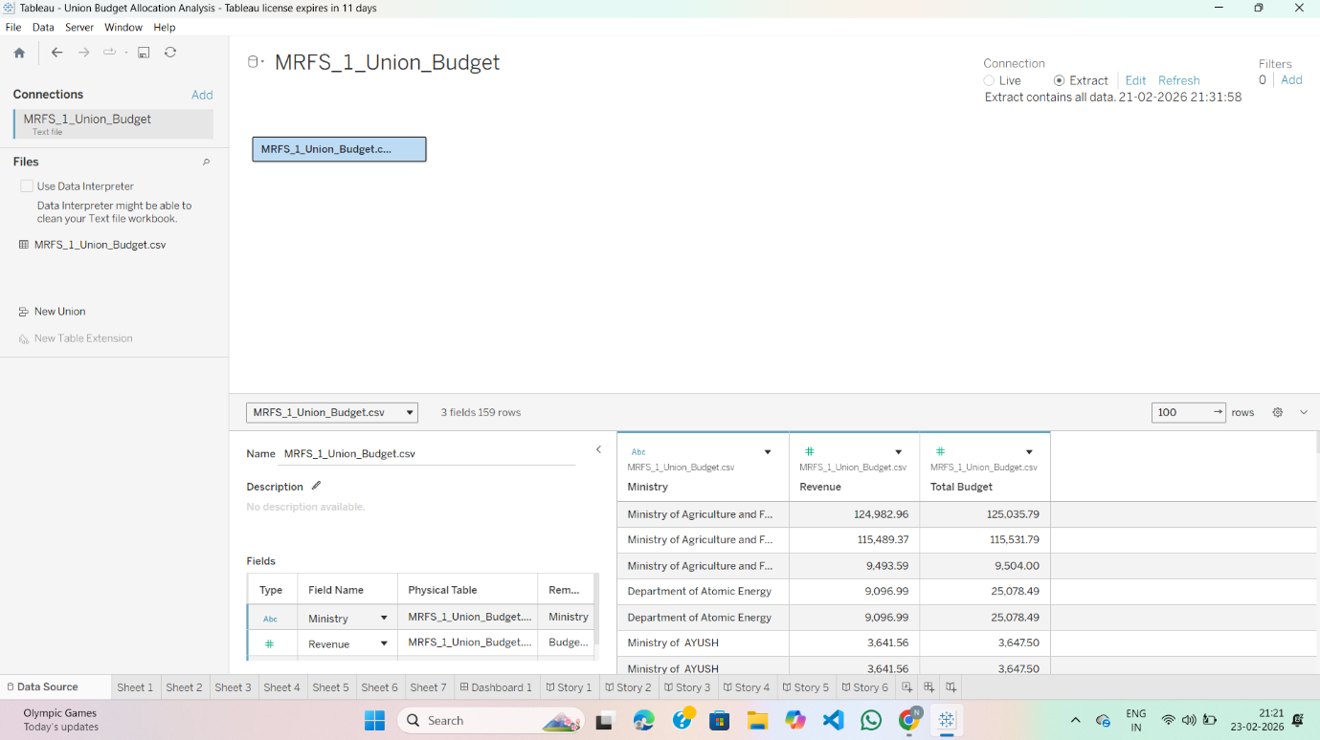
Fig 2: Budget Data Analysis Using Data Analytics Tool

Literature Survey

A literature survey provides an overview of existing studies and research related to Union Budget analysis, public expenditure, and sustainable development. Several studies have emphasized the importance of analyzing government budget allocations to understand economic priorities and long-term development goals. Researchers have highlighted that effective budget planning plays a crucial role in improving social welfare, infrastructure growth, and environmental sustainability.

Many previous studies on the Union Budget of India have focused on sector-wise allocation trends and their impact on economic growth. Research indicates that increased investment in education and healthcare leads to the development of human capital, which is essential for sustainable economic progress. Similarly, higher budget allocations to agriculture and rural development contribute to food security and poverty reduction.

Recent literature also emphasizes the growing importance of infrastructure development and renewable energy investments. Studies reveal that increased spending on infrastructure enhances employment opportunities and improves overall productivity, while renewable energy funding supports environmental sustainability and reduces dependency on fossil fuels. Data analytics and visualization tools have been widely used in these studies to identify trends, compare year-wise data, and generate insights from large financial datasets.

Overall, the literature suggests that data-driven analysis of Union Budget allocations is essential to evaluate government priorities and their alignment with sustainable development goals. This project builds upon existing research by applying data analytics techniques to analyze historical budget data and present insights in a clear and visual manner.

Reference Data

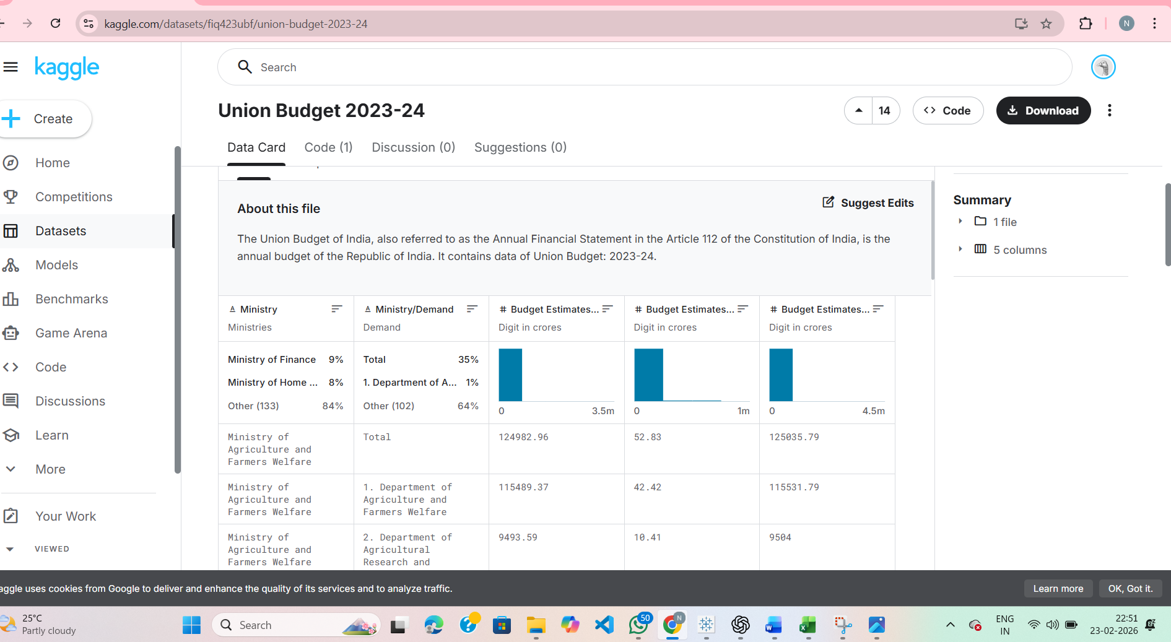
Fig 3: Reference Data Used for Union Budget Allocation Analysis
The dataset used for this project is collected from Kaggle, a well-known and trusted open-source data platform. Kaggle provides a wide variety of real-world datasets contributed by governments, organizations, and data science communities across the globe. These datasets are widely used for academic projects, research work, and industry-level data analysis.

For this project, the dataset related to Union Budget Allocation and Government Expenditure is taken from Kaggle. The dataset contains structured and reliable information such as year-wise budget allocations, sector-wise expenditure, revenue details, and financial trends across different departments. The data is available in CSV format, making it easy to import into databases and analytical tools.

Using a Kaggle dataset ensures data authenticity, accessibility, and consistency. It helps in performing accurate data analysis, visualization, and interpretation to derive meaningful insights. The dataset is suitable for analyzing trends, comparing budget growth over years, and understanding how government spending contributes to sustainable development and economic growth.

Data Collection and Extraction

Data collection is a crucial step in data analytics, as the quality of insights depends on the accuracy and structure of the data used. In this project, the data related to the Union Budget of India is collected from secondary sources. The dataset includes historical budget allocation details across multiple years for key sectors such as education, healthcare, agriculture, infrastructure, and renewable energy.

The collected data is organized in a structured format to make it suitable for analysis. Data extraction involves selecting relevant attributes such as financial year, sector names, and allocated budget amounts. Unnecessary or incomplete information is removed to maintain data consistency. The final dataset is stored in a tabular format using spreadsheet software, enabling easy access and further analysis.

This structured data serves as the foundation for performing analytical operations, trend analysis, and data visualization in later stages of the project. Proper data collection and extraction ensure reliability and accuracy in evaluating the evolution of budget allocations and their impact on sustainable growth.

Data Collection View
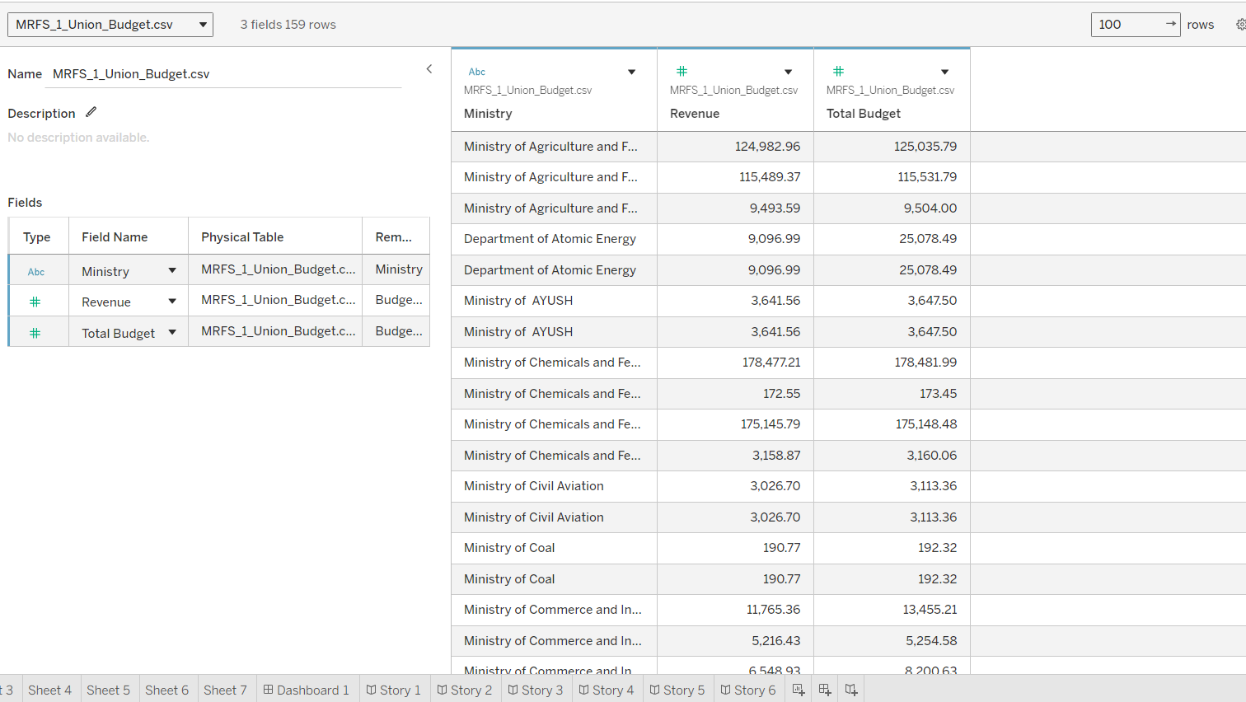
Fig 4: Collected Union Budget Allocation Data for Analysis

Methodology

The methodology defines the systematic approach followed to analyze the evolution of Union Budget allocations and their contribution to sustainable growth. This project adopts a structured data analytics methodology to ensure accurate analysis and meaningful insights. The methodology begins with understanding the project objectives and identifying the key sectors that influence sustainable development, such as education, healthcare, agriculture, infrastructure, and renewable energy.

Initially, historical budget allocation data related to the Union Budget of India is collected from secondary sources and organized in a structured format. The collected data is then cleaned to remove inconsistencies, missing values, and irrelevant information. This step ensures data accuracy and reliability for further analysis. Data preparation also involves formatting numerical values and arranging the dataset year-wise and sector-wise.

After data preparation, analytical techniques are applied to study trends and patterns in budget allocation over multiple years. Comparative analysis is performed to evaluate differences in sector-wise spending and identify priority areas. Visualization techniques such as bar charts, line graphs, and pie charts are used to represent the data clearly and effectively. These visualizations help in understanding changes in government spending and highlighting growth patterns related to sustainable development.

Finally, insights are derived from the analysis to evaluate how budgetary priorities align with long-term economic, social, and environmental sustainability goals. The methodology ensures a clear flow from raw data to insightful conclusions, supporting informed interpretation of budget allocation trends.

Methodology / Analysis Process
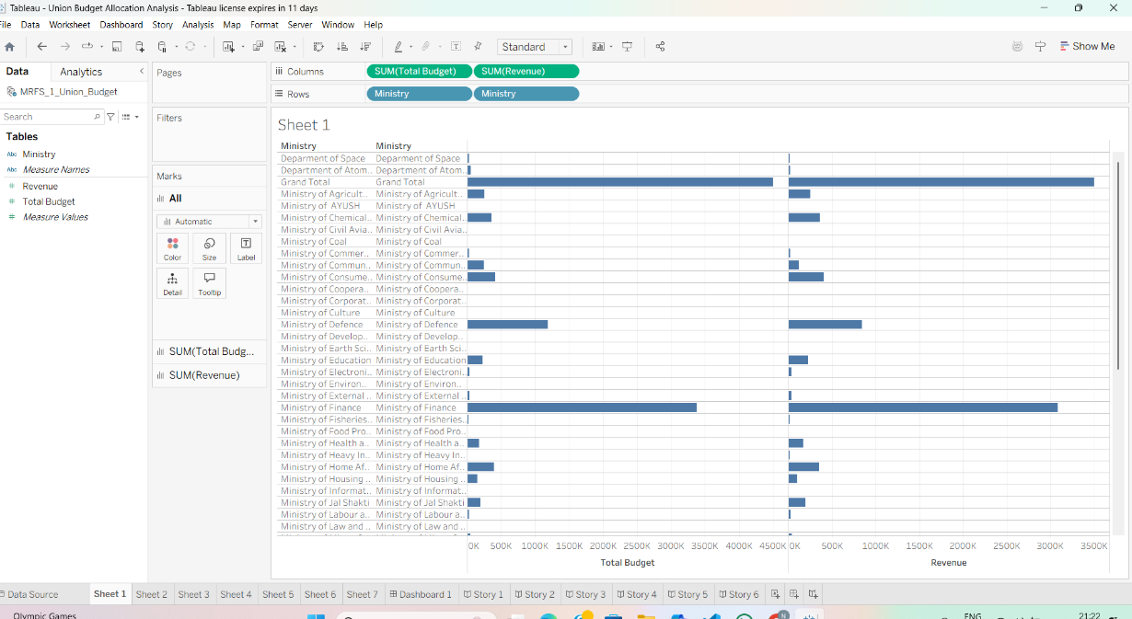
Fig 5: Methodology Followed for Union Budget Allocation Analysis

Flow Chart
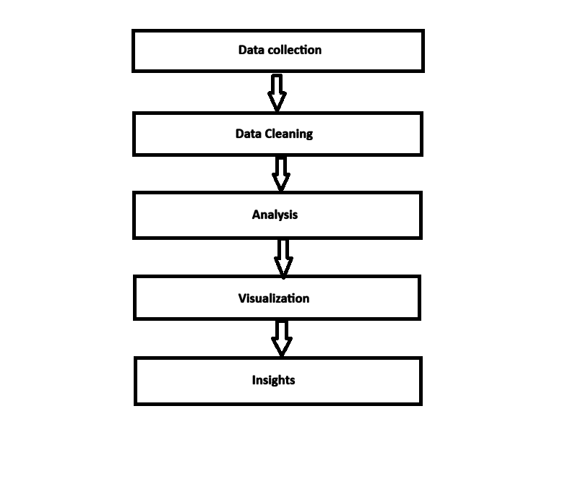
Fig 6: Flow diagram

Data Preparation

Data preparation is a critical step in the data analytics process, as it ensures that the collected data is accurate, consistent, and ready for analysis. In this project, the data related to the Union Budget of India is prepared carefully before performing any analytical operations. Raw budget data collected from secondary sources may contain inconsistencies, missing values, or formatting issues that need to be addressed.

The first stage of data preparation involves verifying the dataset to ensure completeness and correctness. Missing or incorrect values are identified and corrected where necessary. Budget figures are standardized to a common unit (such as rupees in crores) to maintain uniformity across different years and sectors. Column names are clearly defined to represent attributes such as year, sector name, and allocated budget amount.

Next, the data is organized in a structured tabular format, making it easier to perform comparisons and trend analysis. Irrelevant columns or duplicate records are removed to reduce data redundancy. Sorting and filtering operations are applied to arrange the data year-wise and sector-wise, which helps in improving clarity and analysis efficiency.

Proper data preparation enhances the quality of visualizations and ensures that the analytical results are reliable and meaningful. This step forms a strong foundation for accurate data analysis and supports effective interpretation of Union Budget allocation trends related to sustainable growth.

Data Visualization

Data visualization plays a vital role in data analytics by converting numerical data into graphical representations that are easy to understand and interpret. In this project, visualization techniques are used to analyze the historical data of the Union Budget of India and to clearly present sector-wise and year-wise budget allocation trends.

Using data analytics tools such as Excel, Tableau, or Power BI, various charts are created to represent the budget data visually. Line charts are used to show the trend of budget allocations across different years, helping to identify growth or decline in government spending for specific sectors. Bar charts are used for comparing budget allocations between different sectors in a particular year, making it easy to understand priority areas. Pie charts are used to illustrate the proportion of budget distribution among sectors for a selected year.

These visual representations help in identifying patterns, trends, and variations in budget allocations over time. Data visualization simplifies complex financial data and supports better decision-making by providing clear insights into how government spending aligns with sustainable growth objectives. This step ensures that analytical results are communicated effectively and meaningfully.

Final data visualizations
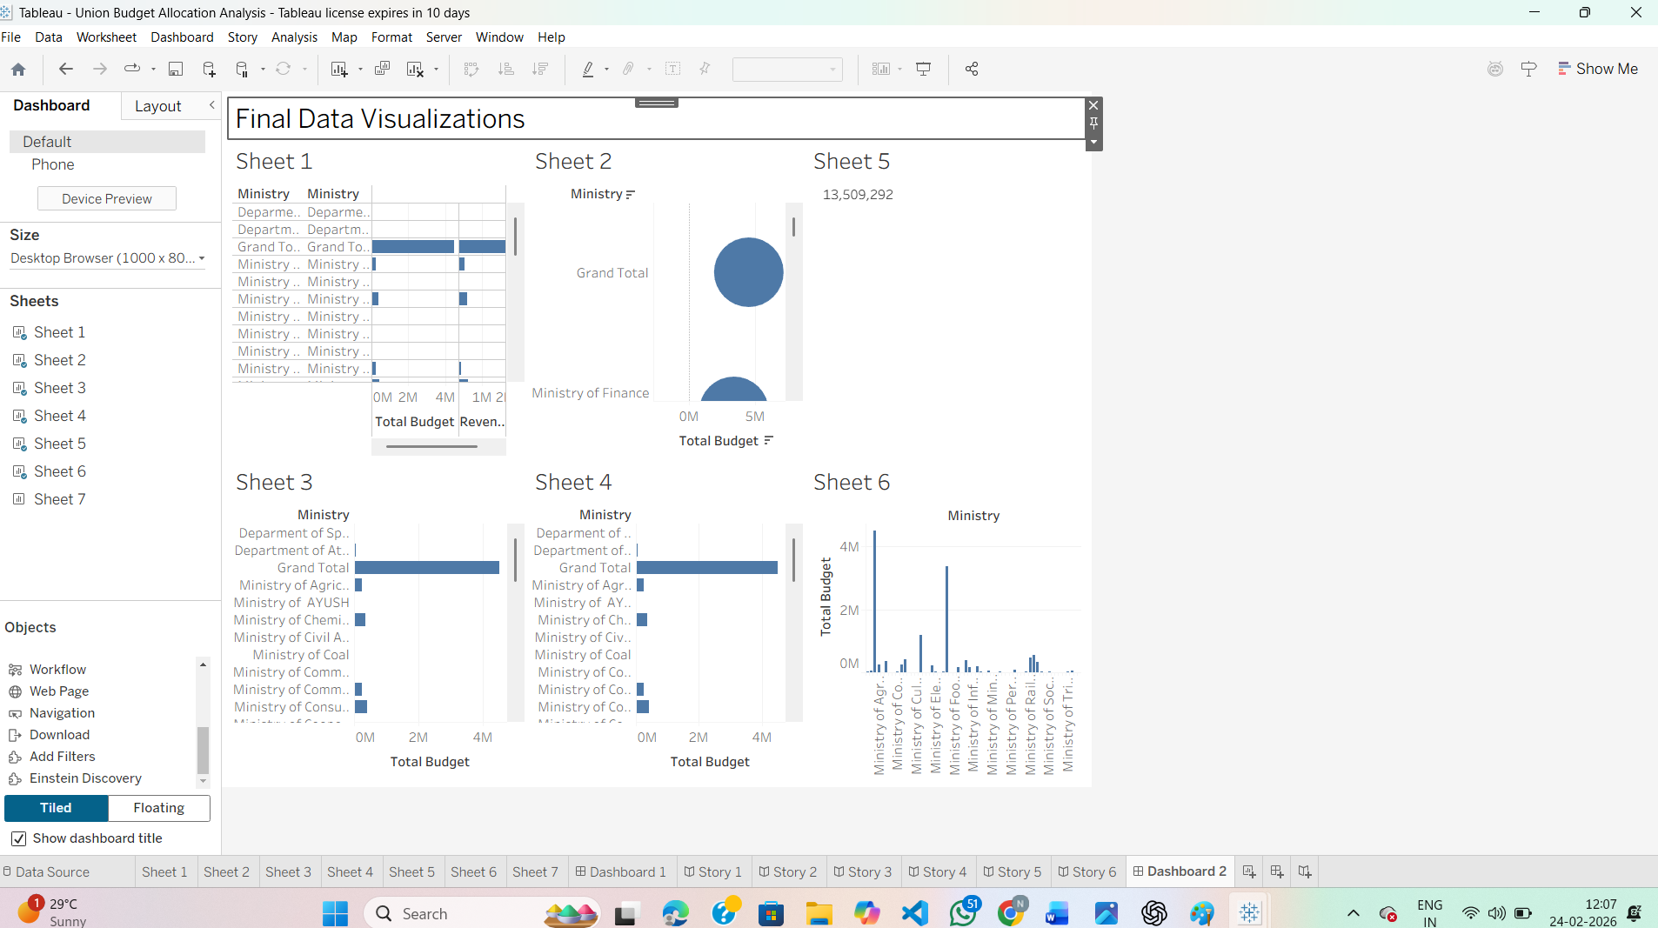
Fig 7: Visual Representation of Union Budget Allocation Trends

Results and Findings

The results obtained from the analysis of the Union Budget of India allocation data provide valuable insights into the government’s spending priorities over the years. The visualizations and analytical comparisons clearly show variations and trends in sector-wise budget allocations, reflecting the evolving focus of the government toward sustainable development.

The analysis indicates a steady increase in budget allocations for education and healthcare sectors, highlighting the government’s emphasis on human capital development and public welfare.

Increased spending in these sectors supports long-term economic growth by improving literacy levels, healthcare infrastructure, and overall quality of life. Agriculture-related budget allocations also show gradual growth, indicating continued support for farmers, rural development, and food security.

Infrastructure development emerges as one of the highest-funded sectors across the analyzed years. The consistent rise in infrastructure spending reflects the government’s objective to strengthen transportation, communication, and urban development, which are essential for economic expansion. Additionally, the analysis reveals a noticeable increase in renewable energy budget allocations in recent years, demonstrating a strong commitment toward environmental sustainability and clean energy initiatives.

Overall, the findings suggest that Union Budget allocations increasingly align with sustainable growth objectives by balancing economic development, social welfare, and environmental protection. The results confirm that data analytics and visualization techniques are effective tools for interpreting complex financial data and deriving meaningful policy insights.

Social and Business Impact

The analysis of the Union Budget of India allocation has significant social and business implications. By examining how government funds are distributed across key sectors, this project highlights the role of financial planning in promoting inclusive and sustainable development.Increased budget allocation toward education and healthcare contributes directly to social welfare by improving literacy rates, healthcare accessibility, and overall living standards of the population.

From a social perspective, higher investment in agriculture and rural development supports farmers’ income, enhances food security, and reduces regional inequalities. The growing focus on renewable energy reflects the government’s commitment to environmental protection and climate sustainability, which benefits society by reducing pollution and encouraging the use of clean energy sources. Infrastructure development improves connectivity, employment opportunities, and access to essential services, thereby enhancing the quality of life.

From a business and economic standpoint, increased government spending on infrastructure and energy sectors creates a favorable environment for industrial growth and private investments. Businesses benefit from improved logistics, better transportation networks, and stable energy supply. Data-driven analysis of budget allocations also supports policymakers and organizations in making informed decisions, forecasting future investments, and aligning business strategies with government priorities.
Overall, this project demonstrates how data analytics can be used as an effective tool to evaluate policy decisions and their broader impact on society and the economy. The insights gained from this analysis help in understanding the relationship between government spending and sustainable national development.

Conclusion

This project successfully analyzed the evolution of sector-wise budget allocations in the Union Budget of India using data analytics techniques. By examining historical budget data, the study provided meaningful insights into how government spending priorities have shifted over the years to support sustainable economic and social development.

The analysis revealed that increased investments in education, healthcare, infrastructure, agriculture, and renewable energy reflect the government’s long-term vision for inclusive growth and sustainability. Data visualization techniques played a key role in simplifying complex financial data and highlighting trends, comparisons, and growth patterns across different sectors. These insights help in understanding how public expenditure contributes to human development, economic expansion, and environmental protection.

Overall, the project demonstrates the effectiveness of data analytics in interpreting large-scale financial data and supporting informed decision-making. The findings emphasize that systematic analysis of budget allocations is essential for evaluating policy outcomes and planning future development strategies. This project not only enhanced analytical and visualization skills but also provided a deeper understanding of India’s budgetary planning and its role in achieving sustainable growth.

